YouTube Video Summarization Tool
Assignment Submission
Candidate: Madhav Chawla
Role: Business Analyst Assessment
Date: 16 March 2026

1. Objective
The objective of this project was to build a simple tool that takes a YouTube video link as input and generates a structured summary of the video.
The system helps users quickly understand the key ideas of a video without having to watch the entire content.
The generated output includes:
- Short Summary (3–4 lines)
- Detailed Summary
- Key Bullet Points
- Actionable Insights / Key Takeaways

2. Approach
The objective of this project was to build a simple tool that helps users generate structured summaries from YouTube videos.
During development, the solution was designed with two possible user inputs.

Case 1 – User Provides a YouTube Link
When a user provides a YouTube video link, the system guides the user to a free AI-based tool that can extract and summarize the video content.
This approach was chosen because direct transcript extraction from YouTube may require API integrations or additional technical setup. By guiding the user to a free AI summarization tool, the system ensures that users can still quickly obtain insights from the video without complex integrations.
This allows the system to remain simple while still enabling users to summarize YouTube videos effectively.

Case 2 – User Provides a Transcript
If the user provides the transcript of a video directly, the system processes the text using an AI model.
The AI analyzes the transcript and generates a structured output that includes:
- Short Summary (3–4 lines)
- Detailed Summary
- Key Bullet Points
- Actionable Insights / Key Takeaways
This enables the system to convert long transcripts into clear and structured insights.

3. System Workflow
The workflow of the system can be summarized as follows:
User enters YouTube link
↓
System provides access to an AI tool for video summarization
↓
User retrieves summary or transcript
↓
User pastes transcript into the system
↓
AI processes the text
↓
Structured summary is generated

4. Edge Cases Considered
While designing the system, the following edge cases were considered to ensure the tool behaves reliably across different types of inputs.

1. Videos with No Transcript Available
Some YouTube videos do not provide captions or transcripts. Since transcripts are required for summarization, the system informs the user that a transcript is not available and suggests trying another video or providing a transcript manually.

2. Very Long Videos Where Transcript Size May Exceed Model Limits
Long videos can produce very large transcripts that may exceed the input limits of AI models. In such situations, the transcript can be divided into smaller segments and summarized individually, after which the summaries can be combined into a final output.

3. Invalid or Private YouTube Links
If the user enters an invalid YouTube link or a link to a private or restricted video, the system may not be able to access the content. In such cases, the system prompts the user to provide a valid public YouTube URL.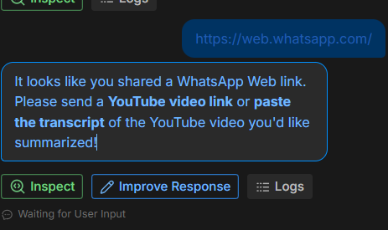

4. Non-English Videos
If the transcript is in a language other than English, the system can still process the content. The output can either be generated in the original language or translated into English if the user specifically requests the summary in English.
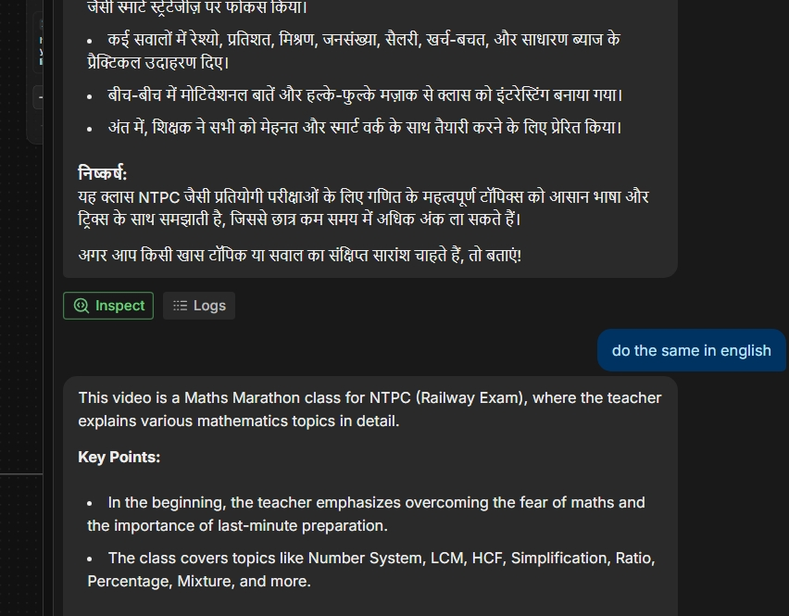

5. Short-Form Videos with Very Little Transcript
Short videos may contain very limited transcript content, which may result in shorter summaries or fewer insights. The system still attempts to generate meaningful output based on the available information.

5. Challenges Faced
During the development of this prototype, a few practical challenges were encountered.

1. API Access for Transcript Extraction
One of the main challenges was obtaining reliable API access for automatically extracting YouTube transcripts and processing them with an AI model. Many services that provide transcript extraction or AI summarization require API keys or paid access.
Since the objective of the assignment was rapid prototyping and experimentation with AI tools, obtaining a stable free API integration within the limited time available was challenging.
To address this, I designed an alternative workflow where users can leverage existing free AI tools to extract summaries from video links. The system then allows users to paste transcripts directly for structured summarization.
This approach ensured that the core objective of the assignment demonstrating the ability to design a working AI-assisted workflow was still achieved.

2. Ensuring Structured Output
Another challenge was ensuring that the AI consistently generates summaries in the required format. This was addressed by designing prompts that guide the AI to return structured outputs including short summaries, detailed summaries, key points, and actionable insights.

3. Handling Different Types of Input
The system needed to handle both YouTube links and transcript inputs. Designing a workflow that clearly guides users depending on the input type was an important part of the implementation.

